Media credits list
Full size images stored on internal website
Apps for Enquiry 2 Ancient Baghdad

Pelmanism: 4 new toys, 4 ancient toys
DESCRIPTION | THUMBNAIL | CREDITS
modern blocks | 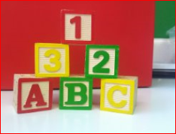 | https://pixabay.com/p-397143/?no_redirect CC0
modern scooter | 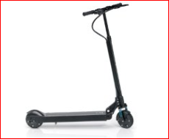 | https://en.wikipedia.org/wiki/Electric_kick_scooter#/media/File:Egret_One.jpg CC0
modern balls | 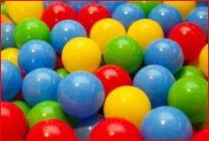 | https://pixabay.com/en/background-ball-play-balls-colorful-71699/ CC0
modern dice | 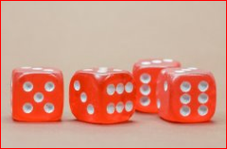 | https://pixabay.com/en/cube-game-cube-instantaneous-speed-568191/ CC0
ancient toy figures | 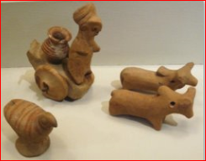 | https://en.wikipedia.org/wiki/Harappa#/media/File:Harappan_small_figures.jpg CC BY 2.0
ancient Game of Ur | 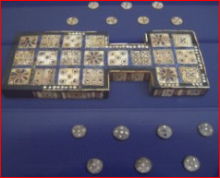 | https://en.wikipedia.org/wiki/Royal_Game_of_Ur#/media/File:British_Museum_Royal_Game_of_Ur.jpg CC0
ancient pegs & holes | 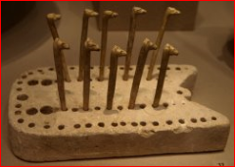 | https://www.flickr.com/photos/mararie/5954586989 https://creativecommons.org/licenses/by-sa/2.0/
ancient dice | 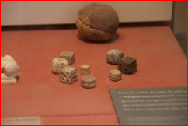 | https://www.flickr.com/photos/eerko/7190233524/in/album-72157629376604380/ https://creativecommons.org/licenses/by-nc-nd/2.0/

